The app Köna is a similar app like the one we will try to build.

Who is “the user”?

The app targets all clubs that are not committed to use a “Regestrierkasse” in Austria.

Purpose and general category of the app? In which situations will the app be used? What are the functions of the app?

The app is used to give servers of a club, at specific events the possibility to be efficient in the order process and minimize the time a guest needs to wait for his food and drinks.

Therefore there has to be a server for the app and an administrator making all adjustments before using the app. But after the admin is done the waiters are possible to create orders for specific tables with different foods and drinks. Also there is the possibility for the administrator to block some food or drinks so the waiters are not able to order them for a specific time. Also there is the possibility to get help at paiing the bills which are open (choosing which meals and drinks they had and adding up the price).

How is the input / output realized? List user interface elements you detect!

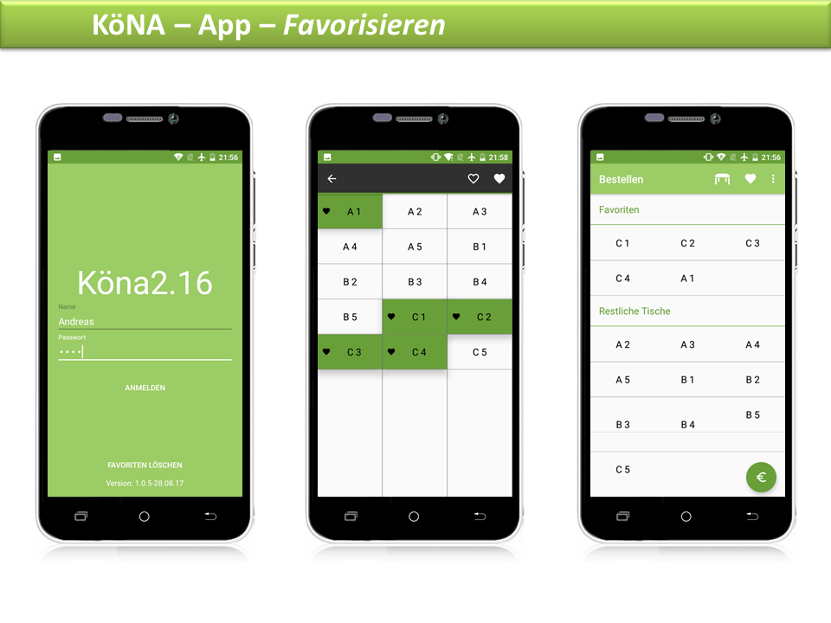

There is first a login, afterwards there is the selection of tables. Afterwards there should be a ordersite. The tables are buttons.

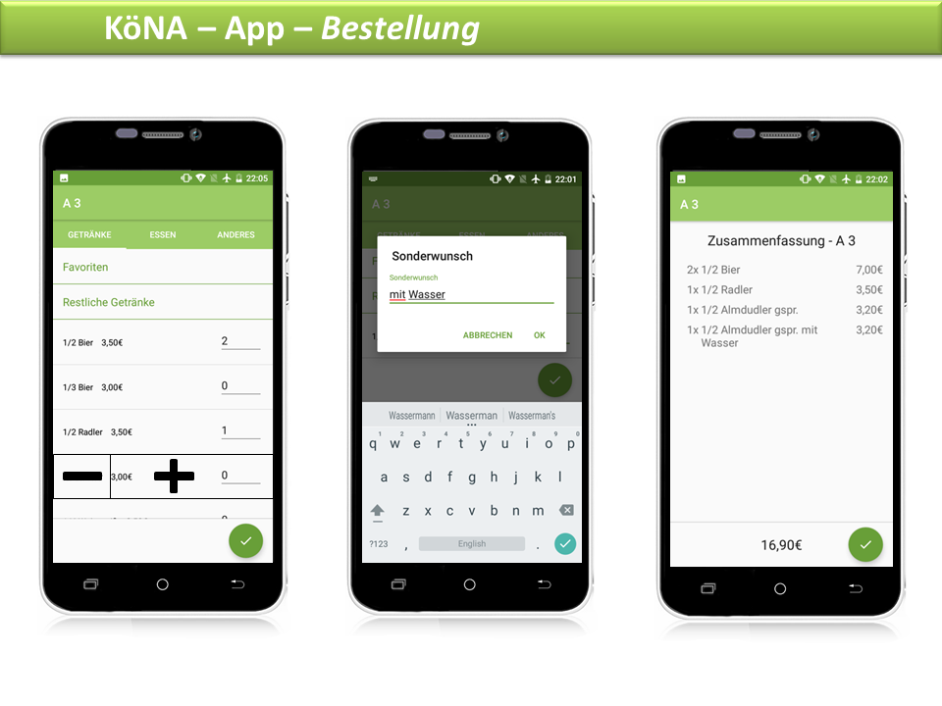

Is the app context-aware ? Which sensors are used?

The only sensore used is the touch screen

Does the app use a wireless network? Which?

The app uses wlan where only the other components of the system are also connected to

Name one property of the app you think is most special and attractive ?

It makes waiters far more efficient and it is far more funny for all than the normal way of waiting on a event of an club.

How does the app make money? (Fee, in-app ads, in-app purchases, sponsorship, …)

The user has to rent the server and the rest of the hardware for the time of the festival.